**ALDRIN L. BALABIS**

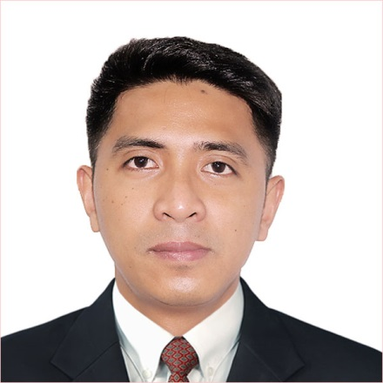

**Address: 147 Mrr St. Pineda,Pasig City**

**Mobile number:** (+63) 923-970-6447

**Home tel. no**.: (+632) 967-6029

**E-mail:** [davidbalabis@gmail.com](mailto:davidbalabis@gmail.com)

**_________________________________________________________________________________**

*A competent Training and development Chef expert in creating menus through research and development, analyzing their critical control points to deliver safe and quality food, and establishing systems and standards for product consistency. Striving for a global career where I can best use and develop further my skills and knowledge in the hospitality industry.*

**WORK EXPERIENCES**

* **Company Name: Butcher’s Lab., Inc.**

**Position:** Training and R&D Head **Period:** January 2018 to September 2019

* Develops recipes and create kitchen standards.
* Collaborates with purchasing department with regards to supplier sourcing.
* Measures cost of each menu necessary in the determination of profitability and value-for-money of the product.
* Setting fish-bone analysis of process flow from “farm-to-fork” mission.
* Facilitates kitchen standards trainings for staff.
* Monitors par stock levels of inventories.
* Ensures food safety and sanitation in all kitchen areas.
* **Company Name: Standard Hospitality Group**

**Position:** Training and R&D officer **Period:** April 2017 to December 2017

* Oversaw staff trainings both in front and back of the house.
* Created restaurant manuals essential in product standardization and consistency.
* Worked with Marketing Department by preparing food used in product advertisements and launchings.
* Assisted executive chef in product innovation, costing, and standardizing recipes.

**Position:** Kitchen Trainer **Period:** May 2015 to March 2017

* Designed kitchen lay-outs for operational efficiency.
* Facilitated actual back of the house trainings.
* Occasionally acted as a reliever to the Dining Manager and/or Kitchen Manager in charge to a certain branch store.

**Position:** Junior Cook **Period:** May 2013 to April 2015

* Inspected kitchen areas to guarantee sanitation and safety of the food being prepared.
* Prepared and set-up food orders of customers.
* Designed kitchen lay-outs for operational efficiency.
* Facilitated actual back of the house trainings.
* **Company Name: Tokyo Tokyo Phils.**

**Position:** Product Quality Controller **Period:** February 2009 to March 2014

* Prepared and set-up orders of customers.
* Maintained cleanliness in the kitchen areas and helped other staff to clean the entire store and organize supplies and inventories.
* **Company Name: KFC Phils.**

**Position:** Service crew **Period:** May 2006 to August 2008

* Prepared and served customer orders swiftly and accurately.
* Performed cleaning duties in the dining areas.
* Occasionally done cashiering functions.

**TRAININGS/SEMINARS ATTENDED**

**May 3, 2017 USMEF Seminar on Quality of US Meat and Meat Handling Techniques**

SHG Commissary, San Juan City

**July 2017 Shift Management Program**

7/F RFM Corporate Center, Mandaluyong City

**July 2017 Excel 101**

7/F RFM Corporate Center, Mandaluyong City

**March 2015 HCCP Training**

7/F RFM Corporate Center, Mandaluyong City

**EDUCATIONAL ATTAINMENT**

***Tertiary:***

**S.Y. 2006 to 2007 Rizal Technological University**

Mechanical Technology (Undergraduate**)**

#704 Boni Ave. Cor. Sacrepante, Mandaluyong City

**S.Y. 2007 to 2009 St.John Bosco Institute**

Hotel and Restaurant Management (Undergraduate)

Pasig Rotonda

***Secondary:***

**S.Y. 2001 to 2005 Kapitolyo High School**

San Ignacio St. Bo. Kapitolyo, Pasig City

***Primary:***

**S.Y. 1995 to 2001 Pineda Elementary School**

Banaag St. Brgy. Pineda, Pasig City

**SKILLS/QUALIFICATIONS**

* Possesses great knowledge in hospitality industry and hands-on experiences in cooking
* Fast and accurate preparation of food
* Capable of operating various kitchen equipment
* Can do multi-tasking
* Very precise and keen to details
* Computer literate and able to do administrative works (Basic Excel, Word, PowerPoint, SAP)
* Has good commutation skills (Written/Oral, English/Filipino)
* Works well with others
* Able to work under pressure

**PERSONAL DATA**

**Date of birth:** October 26, 1988

**Place of Birth** : Quezon City

**Age:** 32 y/o

**Height:**  5’8

**Weight:** 57 kgs.

**Gender:** Male

**Civil Status:** Married

**Religion:** Catholic

**Citizenship:** Filipino

**Language spoken:** English/Filipino

**CHARACTER REFERENCES**

*Available upon request*